**Introduction**

Watching this year’s UNC Men’s Basketball team, it is apparent that Caleb Love and efficiency are not the best of friends. It’s beginning to get to the point where I almost get discouraged every time that he touches the ball, feeling as if the possession will either end in a missed shot or turnover. It started to make me wonder, where did this come from? Looking back on the Final Four run from last year, I looked at him as a great scoring option for the Tar Heels, it even felt like other than the National Championship game against Kansas, and the game that he fouled out in against Baylor, he was the best scorer for Hubert Davis’ Heels. To figure out whether this is a random slump that he’s going through this year, or if this is more of the same and his shot against Duke made me forget his inadequacies as a consistent scorer, I decided to look back on that storied Final Four run and calculate some advanced statistics such as his true shooting percentage and his effective field goal percentage. I did so using the box scores provided by ESPN and by creating an algorithm in Python by which I could plug in his box score numbers from different games and it would calculate everything that I wanted for my study a lot more quickly and with a lot more accuracy than I would be able to if I were plugging the numbers into the equations myself. I used the equations from Basketball Reference for true shooting percentage as well as for effective field goal percentage. Why those two specific stats though? I felt it would be valuable to look beyond box score stats such as field goal percentage in order to be able to illustrate whether this year’s slump is a fluke or not. Using effective field goal percentage is important when looking at a player like Caleb, seeing that he is usually more of a high-volume three-point shooter than he is a guy that will dominate down low or in the midrange area, so I felt as if adjusting his field goal percentage to take his three-pointers made into account. I used his true shooting percentage over this run because I felt it was also important to take the number of free throws that he shot into account, seeing that when he becomes aggressive and drives to the basket instead of settling for the three, he can get himself to the line, shooting as many as seven free throws against Marquette in the Round of 64.

**Methods**

To quickly and efficiently acquire these stats, instead of attempting to do the math myself, I left the math to my computer and used my knowledge of python to create a simple algorithm centered around creating a class called “Player”, and using the calculations of the true shooting and effective field goal percentages as functions of the class so that I could quickly pull this data if I needed to, as seen below.

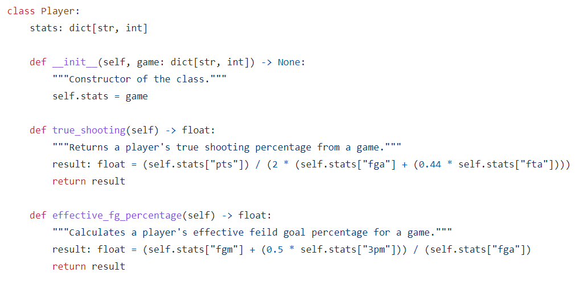

I then created several different objects of class “Player”, each one being one of his games in the tournament, and for each one, I ran the program and printed the data for future use.

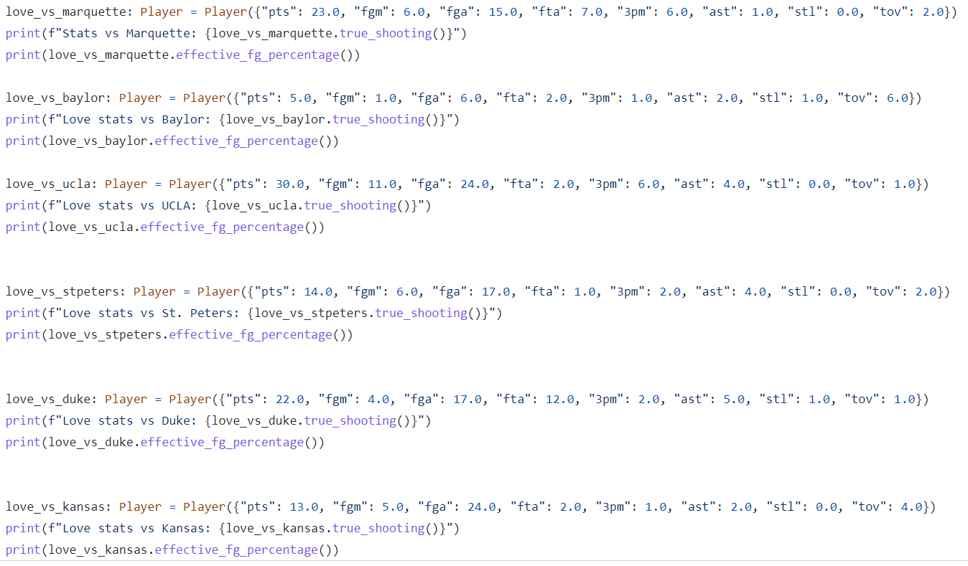

**Results**

After obtaining the data, I then put it into Excel so that it would be easier to visualize without having to just view it in a Python terminal and rerun my program every time I turned my computer back on.

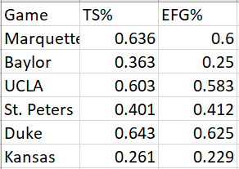

I then used this data to construct two different graphs so I could see whether or not there was any sort of trendline that these were following (the data on the x-axis are the games, with 1 being Marquette and 6 being Kansas, Excel wouldn’t let me use words on the x-axis)

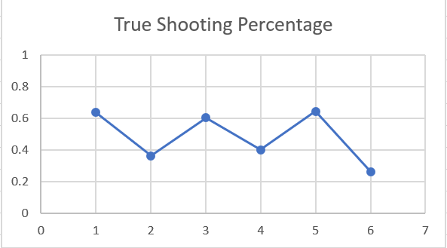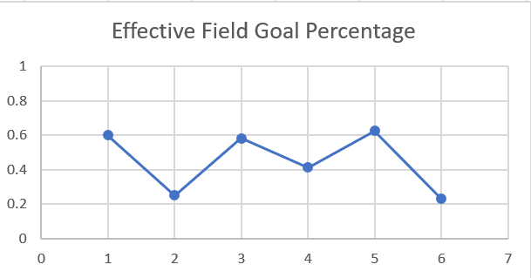

**Conclusion**

Evaluating his true shooting percentage as well as his effective field goal percentage over this six-game stretch does not support that this slump that he’s in right now was a regular thing, but what these numbers do show is what I believe to be the biggest issue that NBA scouts could have with Caleb when he enters into the draft process after his college career, and that is how consistently inconsistent he is. Every game it seems like you’re flipping a coin to try and see which Caleb you’re going to get, the near-elite scorer that UNC got against Marquette, UCLA, and Duke, or the borderline offensive liability that they got against Baylor, St. Peters, and Kansas. However, some of his more negative games need some more context in order to understand the full scope of these stats. In the Baylor game, he was in foul trouble, which limited his minutes in stretches throughout the game, and eventually led to him fouling out. In the Kansas game, he was playing with an ankle injury that he sustained sometime throughout the second half, which could have affected his ability to make shots, so I feel that this game especially should be taken with a grain of salt. The regular season is halfway done, and while his current consistent struggles are something new, I believe that he can still bring it around and become the elite scorer that he has the potential to be, but his past performances point toward a full-force Caleb being an inconsistent second option.

**Sources:**

**ESPN Box Scores:**

<https://www.espn.com/mens-college-basketball/game/_/gameId/401408636>

**Basketball Reference:**

<https://www.basketball-reference.com/about/glossary.html>